**Tag Management in CMP - London**

**Introduction:**

This document is to provide additional details around the tag management in CMP. Current documentation on tag management( for London release) is available [here](https://docs.servicenow.com/bundle/london-it-operations-management/page/product/cloud-management-v2/concept/cloud-tagging.html). Additional FAQs and answers are available [here](https://hi.service-now.com/kb_view.do?sys_kb_id=304e3b35db291b042b6dfb651f961901#v2-4)

However, the documentation and FAQs don’t cover all the details of the behavior of the tag management and this document to should help answers additional questions like:

1. What is the behavior of CMP dealing with tags?
2. How to add new tags to new BPs?
3. How to add new tags to current BPs?
4. How to add specific tags to specific resources?

**What is the behavior of CMP dealing with tags?**

Tags are managed using admin portal > Analyze > Tag > Tag Management. All the tags that are active and are of type ServiceNow or ServiceNow(Custom) are automatically available for CMP blueprints in the Blueprint Container Resource. **If the tags are made visible and users populate the tag fields, they are saved along with the cloud resource. Any tags that are visible, but not populated will not be saved. Tags may be populated and/or manipulated using the policy scripts by modifying custTags object.** See the script in section on **“**How to add specific tags to specific resources?” to find an example of how to manipulate the custTags object. ***The default behavior is CMP is to save all the tags to all resources that are part of the blueprint.* See section later on how to customize this behavior.**

**How to add new tags to new BPs?**

New tags may be added using the tag management UI. Make sure the new tags are visible and are active so that they are available in the Blueprint Container Resource. Any new blueprint creation will automatically inherit the new tags. Additionally, tags can be added to blueprint resources by manipulating the custTags object using policies. The tags added directly to the custTags object will be saved along with the resource, but not in CMP tag management. When the cloud resources are rediscovered, these tags appear as User-defined tags in CMP tag management.

**How to add new tags to current BPs?**

New tags may be added using the tag management UI. Make sure the new tags are visible and are active so that they are available in the Blueprint Container Resource. However, in case of current blueprints, they are not automatically inherited. In order to make them available for use, it is important to “reset” and “publish” from the form in the blueprints. If the blueprint is customized, make sure to use the “Reset with preserved mapping” option during “reset”. Additionally, tags can be added to blueprint resources by manipulating the custTags object using policies as explained in the previous section.

**How to add specific tags to specific resources?**

Policies may be used to modify the default behavior of saving all tags to all resources. This section covers this topic in detail. Assuming that there are two resources – VM and a storage Volume – that are being provisioned, this section provides the steps to add custom tags to these resources. The steps are:

1. Create a custom script to manipulate the tags similar to the example below:

var AddCustomTagsforVM = Class.create();

AddCustomTagsforVM.prototype = Object.extendsObject(sn_cmp.PolicyExecutionBase, {

customScript : function(formData){

// Manipulation of form parameters are supported. Changes in any other attributes

// will be ignored.

// The data available for manipulation is as follows:

// Form Data - for example: StackName can be accessed through formData.StackName

// formData.StackName = "MyStack";

// User Data - for example: User Id can be accessed through this.parameters.userData

// if(this.parameter.userData.userId == 'servicenowuserId')

//this.info("id = " + formData.StackName);

gs.info("@@@ brefore: CustomTags :"+formData.CustomTags);

try {

if(formData.CustomTags && formData.CustomTags != null && formData.CustomTags.trim() != '') {

gs.info("@@@ : CustomTags :"+formData.CustomTags);

var custTags = JSON.parse(formData.CustomTags);

//Add custom tags as shown below

custTags.Environment = 'Prod';

custTags.SupportTeam ='Server Support';

custTags.backup = "Yes";

custTags.AutoStart = "yes";

formData.CustomTags = JSON.stringify(custTags);

}

}catch(e) {

gs.info("@@@ the error is :"+e);

}

return formData;

},

execute: function() {

if(this.parameters != null && this.parameters.formData != null){

var inputData = JSON.parse(JSON.stringify(this.parameters.formData));

var outputFormData = this.customScript(inputData);

if( outputFormData != null){

this.parameters.formData = outputFormData;

}

}

var output = {};

output.answer = this.parameters;

return JSON.stringify(output);

},

type : 'AddCustomTagsforVM'

});

var AddCustomTagsforVMObj = new AddCustomTagsforVM(inputAttributes);

var outputParams = AddCustomTagsforVMObj.execute();

gs.info( "Output of script is = " + outputParams);

1. The script above may be used for the VM resource. Create additional scripts as needed to be used for the other resource and add custom tags as needed.
2. Add a policy to run the above custom script during pre-operation step on Virtual server as shown below.

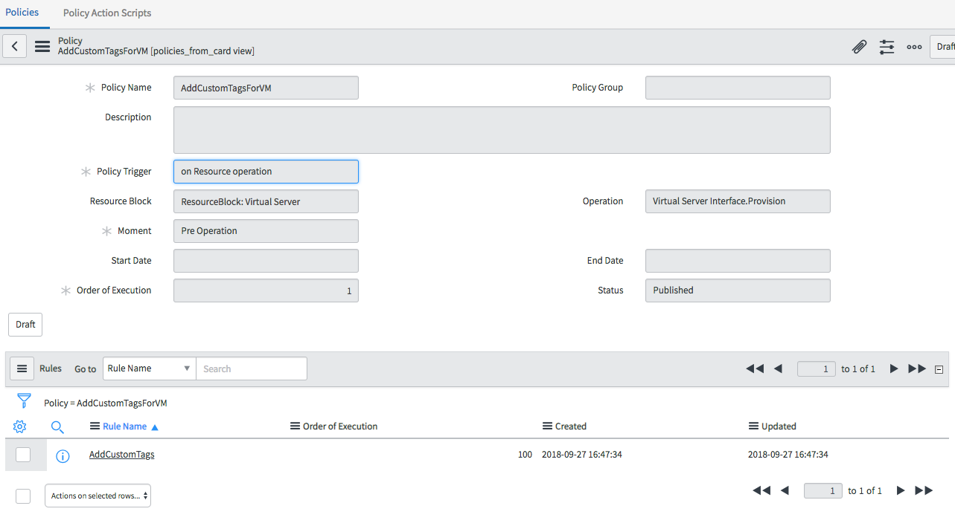

1. Create similar policy for storage to run the policy script for Storage volume provision as shown below

